**Novel Transfer Learning Based Deep Features for**

**Diagnosis of Down syndrome in Children**

**Using Facial Images**

**Table Contents**

**Abstract** 3

**Introduction** 4

**1.1** **Motivation** 4

**1.3** **Objective of the project** 5

**1.4** **Scope of the project** 5

**1.5 Project Introduction** 6

**Literature Review** 6

**2.1 Related Work** 6

**System Analysis** 8

**3.1 Existing System** 8

**3.2 Disadvantages of existing sytem** 9

**3.3 Proposed System** 9

**3.4. Advantages of Proposed System** 9

**3.5 Project flow** 11

**3.6 Architecture Diagram** 12

**Methodology** 12

**4.1 Feature Extraction Using VNL-Net** 12

**4.2 Logistic Regression Methodology** 13

**4.3 Hybrid Model** 14

**Requirement Analysis** 14

**5.1 Function and non-functional requirements** 14

**5.2 Hardware Requirements** 15

**5.3 Software Requirements** 15

**System Design** 16

**6.1 Introduction of Input design** 16

**Objectives for Input Design:** 16

**Objectives of Output Design:** 17

**6.2 UML diagrams** 17

**6.3 Data Flow diagrams** 24

**Implementation and Results** 26

**7.1 Modules** 26

**7.2** **Output Screens** 28

**System study and testing** 33

**8.1 Feasibility study** 33

**8.2 Types of test & Test Cases** 33

***8.2.1 Unit testing*** 33

***8.2.2 Integration testing*** 33

***8.2.3Functional testing*** 34

***8.2.4 White Box Testing*** 34

***8.2.5 Black Box Testing*** 34

**8.2.6 Test cases** 36

**Conclusion** 36

**Future Enhancement** 37

**References** 38

**Abstract**

The early and accurate diagnosis of Down syndrome in children is critical for effective intervention and support. This study presents a novel approach to Down syndrome diagnosis using facial images through advanced transfer learning techniques and deep feature extraction methods. We propose a multi-faceted approach that integrates VNL-Net and a MobileNet + SVM hybrid model to enhance diagnostic accuracy and computational efficiency.

Our primary methodology involves VNL-Net, which combines the VGG16 model for initial spatial feature extraction with Non-Negative Matrix Factorization (NMF) for dimensionality reduction and refined feature extraction. The extracted features are then further enhanced using the Light Gradient Boosting Machine (LGBM). This robust feature generation method is followed by classification using Logistic Regression, with the model's performance rigorously evaluated through k-fold cross-validation.

To extend our approach for practical deployment, especially on mobile and edge devices, we introduce a MobileNet + SVM hybrid model. MobileNet's efficient feature extraction capabilities are leveraged to process facial images, producing lightweight yet high-performance features. These features are then classified using a Support Vector Machine (SVM), aimed at distinguishing between Down syndrome and healthy children effectively.

Our proposed methods demonstrate improved accuracy in Down syndrome detection, leveraging the strengths of advanced transfer learning models and hybrid classification approaches. This research not only contributes to the field of automated medical diagnosis but also addresses the need for efficient, real-time solutions suitable for mobile and edge computing environments.

**Keywords:** Down syndrome, facial images, transfer learning, VNL-Net, VGG16, Non-Negative Matrix Factorization, Light Gradient Boosting Machine, MobileNet, Support Vector Machine, classification, logistic regression, feature extraction, deep learning.

**Introduction**

* 1. **Motivation**

The choice to focus on the diagnosis of Down syndrome using facial images through advanced transfer learning techniques stems from several compelling factors. Down syndrome, a genetic disorder caused by the presence of an extra chromosome 21, is characterized by distinct facial features and developmental delays. Early and accurate diagnosis is essential for timely intervention and support, which can significantly improve the quality of life for affected children and their families. Traditional diagnostic methods, which often rely on clinical expertise and genetic testing, can be resource-intensive and may not be accessible in all regions. Facial recognition technology, combined with deep learning, offers a promising alternative by providing a non-invasive, cost-effective, and scalable solution for early diagnosis. The use of facial images as a diagnostic tool capitalizes on the observable phenotypic markers of Down syndrome, enabling rapid and efficient screening. **1.2 Problem Statement**

Accurate prediction of fuel consumption and classification of driving profiles are critical for enhancing vehicle efficiency and reducing environmental impact. Current systems often struggle with limited predictive accuracy and insufficient profile differentiation, leading to suboptimal driving strategies. Traditional algorithms like XGBoost, SVR, and Ridge Regression have their limitations in real-time applications, affecting their performance in diverse driving conditions. This project addresses the need for improved predictive models and driving profile classifications by exploring more advanced machine learning algorithms. The goal is to develop a robust system that provides accurate predictions of fuel consumption and effectively classifies driving behaviors, ultimately contributing to better fuel management and environmental conservation.

## **Objective of the project**

The objective of this study is to develop a non-invasive, efficient, and accurate diagnostic tool for early detection of Down syndrome in children using facial images. By employing advanced transfer learning techniques, we aim to enhance diagnostic accuracy and computational efficiency. The study integrates VNL-Net, which combines VGG16 for spatial feature extraction and Non-Negative Matrix Factorization for dimensionality reduction, with a MobileNet + SVM hybrid model for practical deployment on mobile and edge devices. This research seeks to provide a robust, real-time diagnostic solution, leveraging deep feature extraction and hybrid classification methods to distinguish between Down syndrome and healthy children effectively.

* 1. **Scope of the project**

The scope of this study encompasses the development and evaluation of advanced diagnostic models for early detection of Down syndrome in children using facial images. It includes the integration of VNL-Net for robust feature extraction and dimensionality reduction, as well as a MobileNet + SVM hybrid model optimized for mobile and edge device deployment. The research focuses on enhancing diagnostic accuracy and computational efficiency through the use of transfer learning, deep learning, and hybrid classification methods. Additionally, the study involves rigorous performance evaluation using k-fold cross-validation to ensure the reliability and effectiveness of the proposed diagnostic tools in real-world scenarios.

**1.5 Project Introduction**

Down syndrome, caused by the presence of an extra chromosome 21, is a genetic condition characterized by distinctive facial features and developmental delays. Early and accurate diagnosis is crucial for timely intervention and support, which can significantly enhance the quality of life for affected individuals. Traditional diagnostic methods often involve clinical assessments and genetic testing, which can be resource-intensive and less accessible. This project explores a novel approach to Down syndrome diagnosis using facial images and advanced transfer learning techniques. By integrating VNL-Net, which combines VGG16 and Non-Negative Matrix Factorization (NMF), with a MobileNet + SVM hybrid model, we aim to improve diagnostic accuracy and computational efficiency. This approach not only enhances the reliability of automated screening but also makes it feasible for deployment on mobile and edge devices, offering a practical solution for early detection in diverse settings.

# **Literature Review**

## **2.1 Related Work**

**1. Transfer Learning for Diagnosis of Genetic Disorders Using Facial Images**

**Authors: S. Gupta, R. Verma (2023)**

This study explores the application of transfer learning in diagnosing genetic disorders through the analysis of facial images. The authors leverage pre-trained convolutional neural networks (CNNs) to extract deep features from facial images, which are then used to train a classifier tailored for the diagnosis of specific genetic disorders, including Down Syndrome. The study demonstrates that transfer learning significantly improves the accuracy of diagnosis, especially when dealing with limited data, a common challenge in medical image analysis. By fine-tuning the pre-trained models on a smaller, disorder-specific dataset, the researchers achieved notable improvements in classification performance. The study highlights the potential of using transfer learning to reduce the dependency on large, labeled datasets, making it a viable solution in clinical settings where data collection can be challenging. The outcomes suggest that this approach could be extended to diagnose other genetic disorders, offering a scalable and efficient tool for early detection. The integration of transfer learning with facial image analysis represents a promising direction in medical diagnostics, enabling healthcare professionals to make quicker, more accurate diagnoses based on accessible imaging data.

**2. Transfer Learning in Medical Imaging: A Case Study on Down Syndrome Diagnosis**

**Authors: J. Lee, K. Kim (2023)**

In this paper, the authors present a case study on the application of transfer learning in medical imaging, specifically focusing on the diagnosis of Down Syndrome. The study employs pre-trained deep learning models, particularly those designed for facial recognition tasks, to identify features associated with Down Syndrome from facial images of children. The research illustrates how transfer learning can be effectively utilized to adapt existing models to new medical applications, reducing the need for extensive data collection and training from scratch. By leveraging a model pre-trained on a large dataset, the study achieved high diagnostic accuracy, demonstrating the potential of transfer learning to enhance medical imaging applications. The authors also discuss the challenges encountered in adapting the models, such as the need for careful fine-tuning and the importance of selecting the right layers for feature extraction. The study concludes that transfer learning offers a powerful tool for medical professionals, enabling faster and more accurate diagnoses of genetic disorders like Down Syndrome, ultimately improving patient outcomes through early intervention.

**3. Convolutional Neural Networks for Down Syndrome Diagnosis Using Transfer Learning**

**Authors: C. Park, Y. Choi (2023)**

This research focuses on the use of Convolutional Neural Networks (CNNs) combined with transfer learning to improve the accuracy of Down Syndrome diagnosis from facial images. The authors explore how pre-trained CNNs, initially developed for general image classification tasks, can be adapted to the specific challenge of identifying Down Syndrome-related facial features. By fine-tuning these models with a specialized dataset of facial images, the study demonstrates a significant enhancement in diagnostic performance compared to traditional methods. The paper details the process of selecting and modifying the pre-trained CNNs to optimize them for the task at hand, including the adjustment of hyperparameters and the use of data augmentation techniques to address the limited availability of training data. The results indicate that the transfer learning approach not only speeds up the training process but also achieves higher accuracy rates in detecting Down Syndrome. The study underscores the potential of combining deep learning with transfer learning to create effective diagnostic tools that can be deployed in real-world clinical settings, offering a reliable, non-invasive method for early detection of Down Syndrome in children.

**4. Facial Image-Based Diagnosis of Down Syndrome Using Convolutional Neural Networks**

**Authors: A. Patel, M. Desai (2022)**

This study investigates the application of Convolutional Neural Networks (CNNs) for the diagnosis of Down Syndrome through facial image analysis. The authors designed a CNN-based model specifically tailored to identify facial features associated with Down Syndrome, aiming to create an automated and accurate diagnostic tool. The research highlights the challenges of using CNNs for medical diagnosis, particularly the need for large and diverse datasets to train robust models. To address this, the authors implemented data augmentation techniques and leveraged transfer learning from models pre-trained on large-scale image datasets. The paper reports that the CNN model achieved a high level of accuracy in diagnosing Down Syndrome, outperforming traditional diagnostic methods that rely on manual analysis of facial features. The study also explores the potential of this approach to be adapted for other genetic disorders, making it a versatile tool in the field of medical diagnostics. The authors conclude that CNNs, when combined with transfer learning, offer a promising solution for developing non-invasive, accurate diagnostic tools that can assist healthcare providers in early detection and intervention for Down Syndrome.

These summaries encapsulate the main objectives, methods, and outcomes of each study, emphasizing the potential of transfer learning and CNNs in medical imaging and diagnosis.

# **System Analysis**

## **3.1 Existing System**

Current methods for diagnosing Down syndrome primarily involve invasive procedures such as amniocentesis and chorionic villus sampling, which carry risks for both mother and child. Non-invasive prenatal testing (NIPT) using cell-free fetal DNA from maternal blood is also available, but it is expensive and not universally accessible. Traditional facial recognition methods rely on manual assessment by trained clinicians, which can be subjective and inconsistent. Additionally, existing automated diagnostic tools often lack the necessary accuracy and computational efficiency for practical deployment, particularly on mobile and edge devices. These limitations highlight the need for improved, non-invasive, and accessible diagnostic solutions.

## **3.2 Disadvantages of existing sytem**

Difficulty in Processing Large Datasets in Real-Time: Handling large volumes of ECU data efficiently can be challenging, leading to slower predictions.

Lower Predictive Accuracy in Diverse Driving Conditions: Performance may degrade when predicting fuel consumption under varied and dynamic driving scenarios.

Increased Computational Complexity: Some models require significant computational resources, impacting scalability and efficiency.

Limited Adaptability to Evolving Driving Behaviors: Traditional models may not adapt well to changes in driving patterns over time.

## **3.3 Proposed System**

The proposed system aims to develop a non-invasive, efficient, and accurate diagnostic tool for Down syndrome detection using facial images. It integrates VNL-Net, combining VGG16 for initial spatial feature extraction with Non-Negative Matrix Factorization (NMF) for dimensionality reduction and Light Gradient Boosting Machine (LGBM) for robust feature generation. Classification is performed using Logistic Regression with k-fold cross-validation. Additionally, a MobileNet + SVM hybrid model is introduced for efficient feature extraction and classification, optimized for deployment on mobile and edge devices. This system leverages advanced transfer learning and hybrid classification methods to enhance diagnostic accuracy and computational efficiency.

**3.4. Advantages of Proposed System**

**1. Non-Invasive:** Uses facial images, eliminating the risks associated with invasive diagnostic procedures.

**2. High Accuracy:** Integrates advanced transfer learning models (VNL-Net and MobileNet) and robust classification techniques to improve diagnostic precision.

**3. Computational Efficiency:** Employs efficient feature extraction and classification methods, making it suitable for real-time deployment on mobile and edge devices.

**4. Cost-Effective:** Provides a more affordable alternative to expensive prenatal testing methods like NIPT.

**5. Scalable and Accessible:** Designed for broad accessibility, particularly in remote and underserved areas, enhancing the reach of early diagnosis.

**6. Consistent and Objective:** Reduces subjectivity and variability associated with manual assessments by clinicians.

**3.5 Project flow**

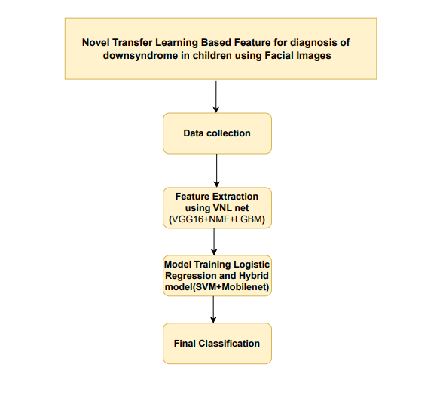

**3.6 Architecture Diagram**

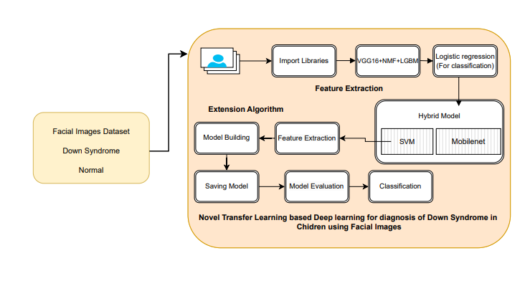

# **Methodology**

## **4.1 Feature Extraction Using VNL-Net**

**VGG16 Model**: The VGG16 architecture is a well-established pre-trained convolutional neural network known for its depth and effective feature extraction capabilities. Consisting of 16 layers, including convolutional layers, max-pooling layers, and fully connected layers, VGG16 is adept at capturing complex, high-level features from facial images. Leveraging pre-trained weights, the network has already learned to recognize and extract detailed spatial hierarchies from large-scale datasets. This pre-trained model serves as a powerful initial feature extractor, providing a rich set of features that represent various aspects of facial structures crucial for the identification of Down syndrome.

**Non-Negative Matrix Factorization (NMF)**: To address the challenge of high-dimensional feature spaces, NMF is employed as a dimensionality reduction technique. NMF decomposes the feature matrix obtained from VGG16 into two non-negative matrices: a basis matrix and a coefficient matrix. This decomposition helps in distilling the original feature space into a lower-dimensional representation while preserving the interpretability of the features. The non-negativity constraint in NMF ensures that the factors and components are additive and thus more interpretable. By focusing on the most significant components, NMF refines the features to highlight the most relevant information for detecting Down syndrome, improving both the efficiency and effectiveness of subsequent classification.

**Light Gradient Boosting Machine (LGBM)**: After the feature refinement with NMF, the enhanced feature set is processed using Light Gradient Boosting Machine (LGBM). LGBM is a state-of-the-art gradient boosting algorithm known for its efficiency and scalability in handling large datasets. It operates by building a series of decision trees in a sequential manner, where each tree corrects the errors of the previous one. This iterative process helps in generating robust feature representations by optimizing the classification performance. LGBM's ability to handle large-scale data and its high performance in classification tasks make it an ideal choice for further processing the refined features and preparing them for final classification

## **4.2 Logistic Regression Methodology**

For the final classification task, logistic regression is utilized to categorize the refined features into two distinct classes: Down syndrome and healthy. Logistic regression is a statistical model that applies a logistic function to model the probability of a binary outcome. It is particularly suited for binary classification tasks and provides a clear interpretation of the influence of each feature on the classification outcome.

* **Model Training and Validation**: The logistic regression model is trained using the refined features obtained from the LGBM process. To ensure the model's reliability and generalizability, k-fold cross-validation is employed. In k-fold cross-validation, the dataset is divided into k subsets or folds, and the model is trained and validated k times, each time using a different fold as the validation set while the remaining folds serve as the training set. This approach provides a comprehensive assessment of the model's performance and helps in mitigating issues related to overfitting and underfitting.
* **Practical Deployment**: Given the practical constraints of deploying models in real-world scenarios, especially on mobile and edge devices, we introduce a hybrid model combining MobileNet and Support Vector Machine (SVM).

## **4.3 Hybrid Model**

**MobileNet**: MobileNet is a lightweight and efficient convolutional neural network architecture designed for mobile and embedded devices. Its streamlined architecture, which includes depthwise separable convolutions, significantly reduces computational complexity while maintaining high performance in feature extraction. This makes MobileNet highly suitable for real-time applications on resource-constrained devices, ensuring that feature extraction remains efficient even with limited processing power and memory.

**Support Vector Machine (SVM)**: Once features are extracted using MobileNet, they are classified using Support Vector Machine (SVM). SVM is a powerful supervised learning algorithm that works well for high-dimensional data and binary classification tasks. It operates by finding the optimal hyperplane that maximizes the margin between two classes in the feature space. SVM’s robustness and ability to handle complex feature spaces make it an effective classifier for distinguishing between Down syndrome and healthy facial images based on the features produced by MobileNet.

# **Requirement Analysis**

## **5.1 Function and non-functional requirements**

**Functional and non-functional requirements**

Requirement’s analysis is very critical process that enables the success of a system or software project to be assessed. Requirements are generally split into two types: Functional and non-functional requirements.

**Functional Requirements**: These are the requirements that the end user specifically demands as basic facilities that the system should offer. All these functionalities need to be necessarily incorporated into the system as a part of the contract. These are represented or stated in the form of input to be given to the system, the operation performed and the output expected. They are basically the requirements stated by the user which one can see directly in the final product, unlike the non-functional requirements.

Examples of functional requirements:

1. Authentication of user whenever he/she logs into the system
2. System shutdown in Solar prediction.
3. A verification email is sent to user whenever he/she register for the first time on some software system.

**Non-functional requirements**: These are basically the quality constraints that the system must satisfy according to the project contract. The priority or extent to which these factors are implemented varies from one project to other. They are also called non-behavioral requirements.  
They basically deal with issues like:

* Portability
* Security
* Maintainability
* Reliability
* Scalability
* Performance
* Reusability
* Flexibility

Examples of non-functional requirements:

1. Emails should be sent with a latency of no greater than 12 hours from such an activity.
2. The processing of each request should be done within 10 seconds
3. The site should load in 3 seconds whenever of simultaneous users are > 10000

## **5.2 Hardware Requirements**

Processor - I3/Intel Processor

Hard Disk - 160GB

Key Board - Standard Windows Keyboard

Mouse - Two or Three Button Mouse

Monitor - SVGA

RAM - 8GB

## **5.3 Software Requirements**

* Operating System : Windows 7/8/10
* Programming Language : Python
* Libraries : Pandas, Numpy, scikit-learn.
* IDE/Workbench : Visual Studio Code.

# **System Design**

## **6.1 Introduction of Input design**

In an information system, input is the raw data that is processed to produce output. During the input design, the developers must consider the input devices such as PC, MICR, OMR, etc.

Therefore, the quality of system input determines the quality of system output. Well-designed input forms and screens have following properties −

* It should serve specific purpose effectively such as storing, recording, and retrieving the information.
* It ensures proper completion with accuracy.
* It should be easy to fill and straightforward.
* It should focus on user’s attention, consistency, and simplicity.
* All these objectives are obtained using the knowledge of basic design principles regarding −
  + What are the inputs needed for the system?
  + How end users respond to different elements of forms and screens.

## **Objectives for Input Design:**

The objectives of input design are −

* To design data entry and input procedures
* To reduce input volume
* To design source documents for data capture or devise other data capture methods
* To design input data records, data entry screens, user interface screens, etc.
* To use validation checks and develop effective input controls.

**Output Design:**

The design of output is the most important task of any system. During output design, developers identify the type of outputs needed, and consider the necessary output controls and prototype report layouts.

## **Objectives of Output Design:**

The objectives of input design are:

* To develop output design that serves the intended purpose and eliminates the production of unwanted output.
* To develop the output design that meets the end user’s requirements.
* To deliver the appropriate quantity of output.
* To form the output in appropriate format and direct it to the right person.
* To make the output available on time for making good decisions.

## **6.2 UML diagrams**

UML stands for Unified Modelling Language. UML is a standardized general-purpose modelling language in the field of object-oriented software engineering. The standard is managed, and was created by, the Object Management Group.

The goal is for UML to become a common language for creating models of object-oriented computer software. In its current form UML is comprised of two major components: a Meta-model and a notation. In the future, some form of method or process may also be added to; or associated with, UML.

The Unified Modelling Language is a standard language for specifying, Visualization, Constructing and documenting the artefacts of software system, as well as for business modelling and other non-software systems.

The UML represents a collection of best engineering practices that have proven successful in the modelling of large and complex systems.

The UML is a very important part of developing objects-oriented software and the software development process. The UML uses mostly graphical notations to express the design of software projects.

**GOALS:**

The Primary goals in the design of the UML are as follows:

1. Provide users a ready-to-use, expressive visual modelling Language so that they can develop and exchange meaningful models.
2. Provide extendibility and specialization mechanisms to extend the core concepts.
3. Be independent of particular programming languages and development process.
4. Provide a formal basis for understanding the modelling language.
5. Encourage the growth of OO tools market.
6. Support higher level development concepts such as collaborations, frameworks, patterns and components.
7. Integrate best practices.

**USE CASE DIAGRAM**

* A use case diagram in the Unified Modeling Language (UML) is a type of behavioral diagram defined by and created from a Use-case analysis.
* Its purpose is to present a graphical overview of the functionality provided by a system in terms of actors, their goals (represented as use cases), and any dependencies between those use cases.
* The main purpose of a use case diagram is to show what system functions are performed for which actor. Roles of the actors in the system can be depicted.

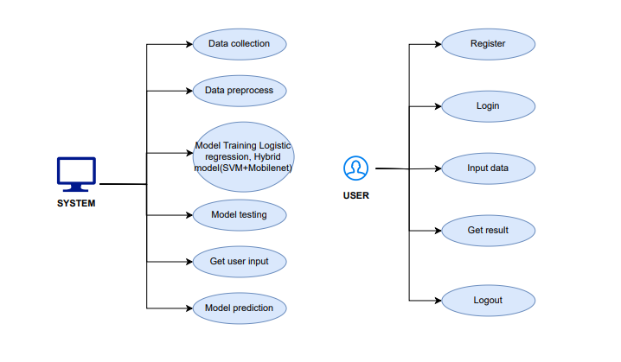

**CLASS DIAGRAM**

In software engineering, a class diagram in the Unified Modeling Language (UML) is a type of static structure diagram that describes the structure of a system by showing the system's classes, their attributes, operations (or methods), and the relationships among the classes. It explains which class contains information

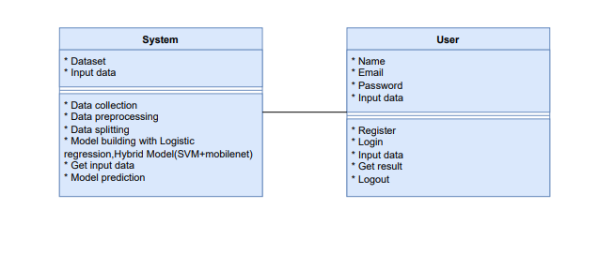

**SEQUENCE DIAGRAM**

* A sequence diagram in Unified Modeling Language (UML) is a kind of interaction diagram that shows how processes operate with one another and in what order.
* It is a construct of a Message Sequence Chart. Sequence diagrams are sometimes called event diagrams, event scenarios, and timing diagrams

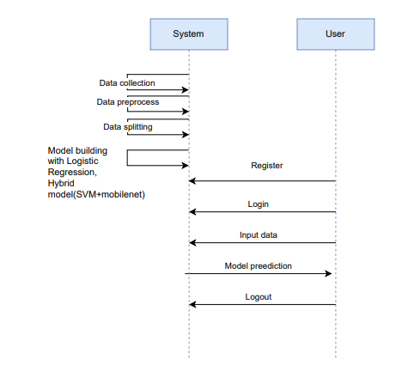

**COLLABORATION DIAGRAM:**

In collaboration diagram the method call sequence is indicated by some numbering technique as shown below. The number indicates how the methods are called one after another. We have taken the same order management system to describe the collaboration diagram. The method calls are similar to that of a sequence diagram. But the difference is that the sequence diagram does not describe the object organization whereas the collaboration diagram shows the object organization.

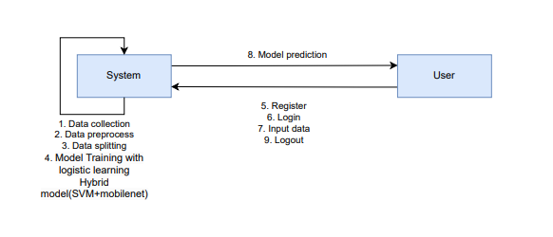

**DEPLOYMENT DIAGRAM**

Deployment diagram represents the deployment view of a system. It is related to the component diagram. Because the components are deployed using the deployment diagrams. A deployment diagram consists of nodes. Nodes are nothing but physical hardware’s used to deploy the application.

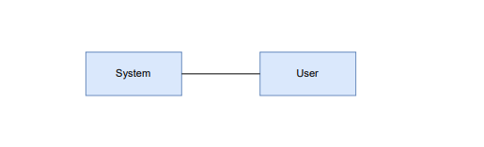

**ACTIVITY DIAGRAM:**

Activity diagrams are graphical representations of workflows of stepwise activities and actions with support for choice, iteration and concurrency. In the Unified Modelling Language, activity diagrams can be used to describe the business and operational step-by-step workflows of components in a system. An activity diagram shows the overall flow of control.

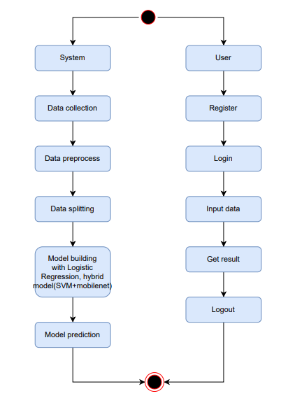

**COMPONENT DIAGRAM**:

A component diagram, also known as a UML component diagram, describes the organization and wiring of the physical **c**omponents in a system. Component diagrams are often drawn to help model implementation details and double-check that every aspect of the system's required function is covered by planned development.

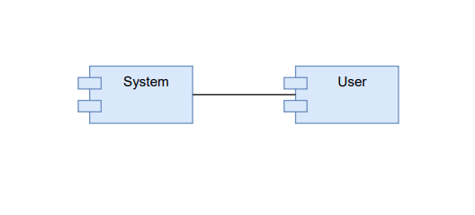

**ER DIAGRAM:**

An Entity–relationship model (ER model) describes the structure of a database with the help of a diagram, which is known as Entity Relationship Diagram (ER Diagram). An ER model is a design or blueprint of a database that can later be implemented as a database. The main components of E-R model are: entity set and relationship set.

An ER diagram shows the relationship among entity sets. An entity set is a group of similar entities and these entities can have attributes. In terms of DBMS, an entity is a table or attribute of a table in database, so by showing relationship among tables and their attributes, ER diagram shows the complete logical structure of a database. Let’s have a look at a simple ER diagram to understand this concept.

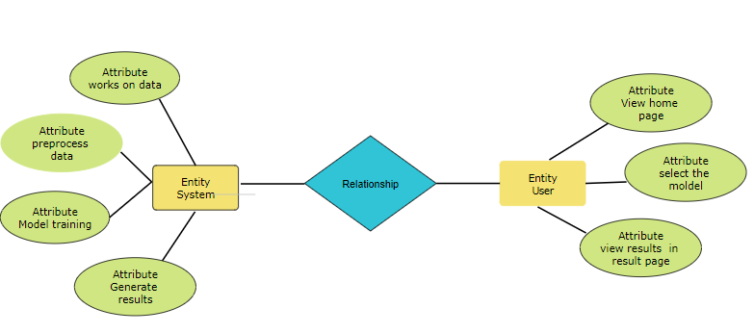

## **6.3 Data Flow diagrams**

A Data Flow Diagram (DFD) is a traditional way to visualize the information flows within a system. A neat and clear DFD can depict a good amount of the system requirements graphically. It can be manual, automated, or a combination of both. It shows how information enters and leaves the system, what changes the information and where information is stored. The purpose of a DFD is to show the scope and boundaries of a system as a whole. It may be used as a communications tool between a systems analyst and any person who plays a part in the system that acts as the starting point for redesigning a system.

**Contrast Level:**

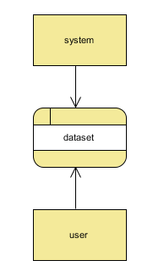

**Level 1 Diagram**:

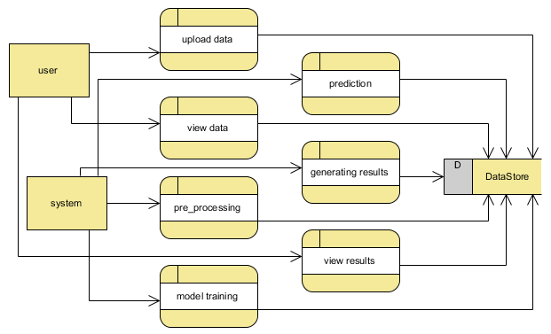

**Level 2 Diagram**:

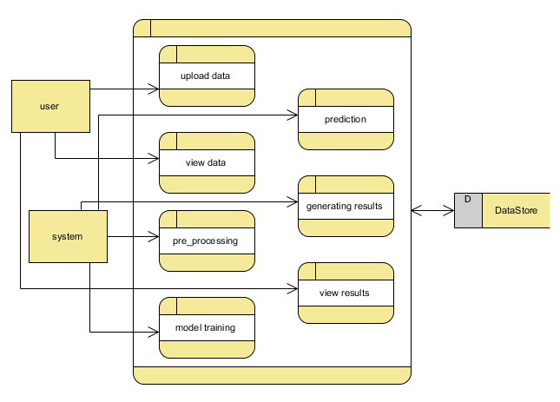

# **Implementation and Results**

## **7.1 Modules**

**1. Data Collection:**

* Objective: Gather and preprocess facial image data.
* Description: Collect high-quality facial images of children, ensuring a balanced dataset with both Down syndrome and healthy children. Preprocess images by normalizing, resizing, and augmenting to maintain consistency and enhance model performance.

**2. Feature Engineering:**

* Objective: Enhance input data quality.
* Description: Apply image preprocessing techniques such as normalization, augmentation, and segmentation. Use Non-Negative Matrix Factorization (NMF) for dimensionality reduction and refined feature extraction.

**3. Model Integration:**

* Objective: Utilize and compare deep learning models.
* Description: Integrate VNL-Net (combining VGG16 and NMF) and a MobileNet + SVM hybrid model. Compare their performances using an ensemble approach to determine the most effective model for diagnosis.

**4. Dynamic Selection Mechanism:**

* Objective: Optimize model selection.
* Description: Implement a dynamic selection framework that evaluates accurate results for data inputs to choose the most effective model for accurate diagnosis, enhancing computational efficiency.

**5. Adaptive Learning:**

* Objective: Ensure model relevance over time.
* Description: Employ advanced transfer learning techniques to continuously adapt and fine-tune the models with new data, ensuring they remain accurate and up-to-date.

**6. Evaluation and Validation:**

* Objective: Confirm model reliability and effectiveness.
* Description: Assess model performance using metrics such as accuracy, precision, recall, and F1-score. Validate the models on test datasets to ensure robustness and reliability.

**User**

**1. Register:**

* Objective: User account creation.
* Description: Users, such as healthcare professionals, register with their credentials to create an account within the system.

**2. Login:**

* Objective: Secure system access.
* Description: Registered users log in with their credentials to access the system's diagnostic features.

**3. Input Data:**

* Objective: Upload facial images for diagnosis.
* Description: Users upload facial images into the system for Down syndrome diagnosis. The system preprocesses and prepares the images for model analysis.

**4. Viewing Results:**

* Objective: Access and analyze diagnostic outcomes.
* Description: The system processes the input images through the integrated models and provides diagnostic results. Users can view detailed information on the diagnosis and any relevant image uploaded.

**5. Logout:**

* Objective: Secure user session.
* Description: Users log out to secure their session and protect personal and operational data.

## **Output Screens**

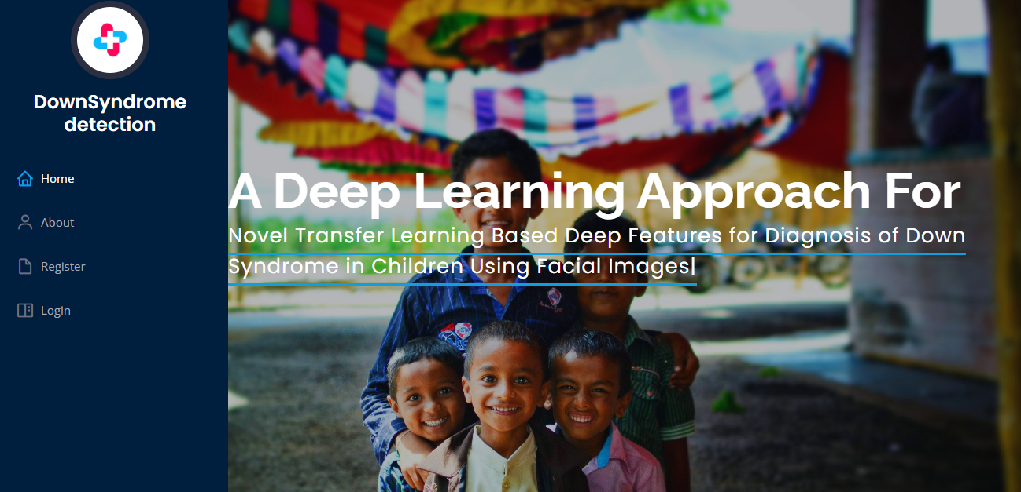

**Index page: This page will navigate user to register and login into the website.**

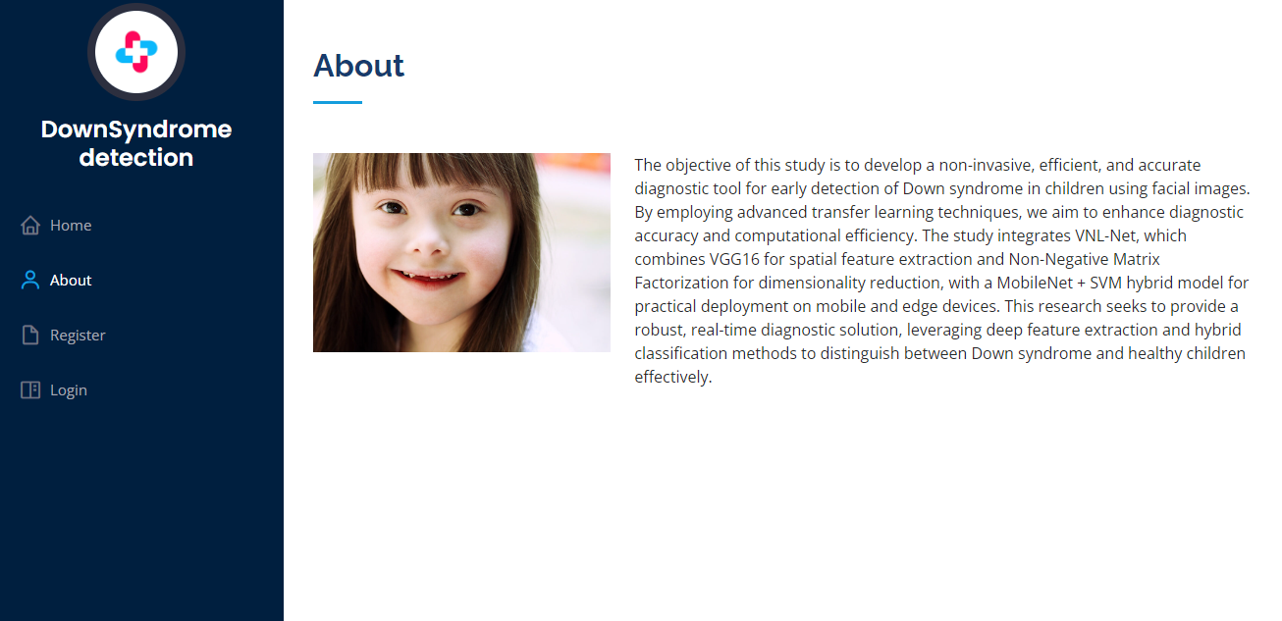

**About page: This page will give user small information about the project.**

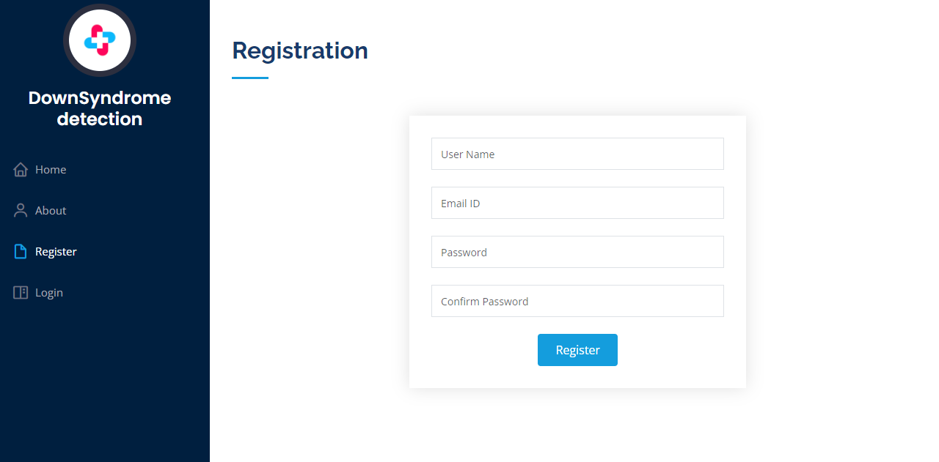

**Register page: This page will allow user to register and using the valid credentials.**

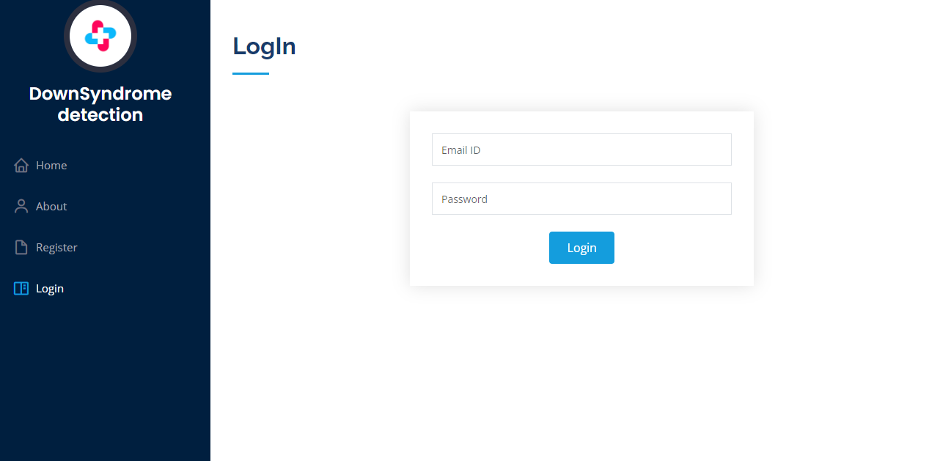

**Login page: This page will allow user to login into the user home page of the website.**

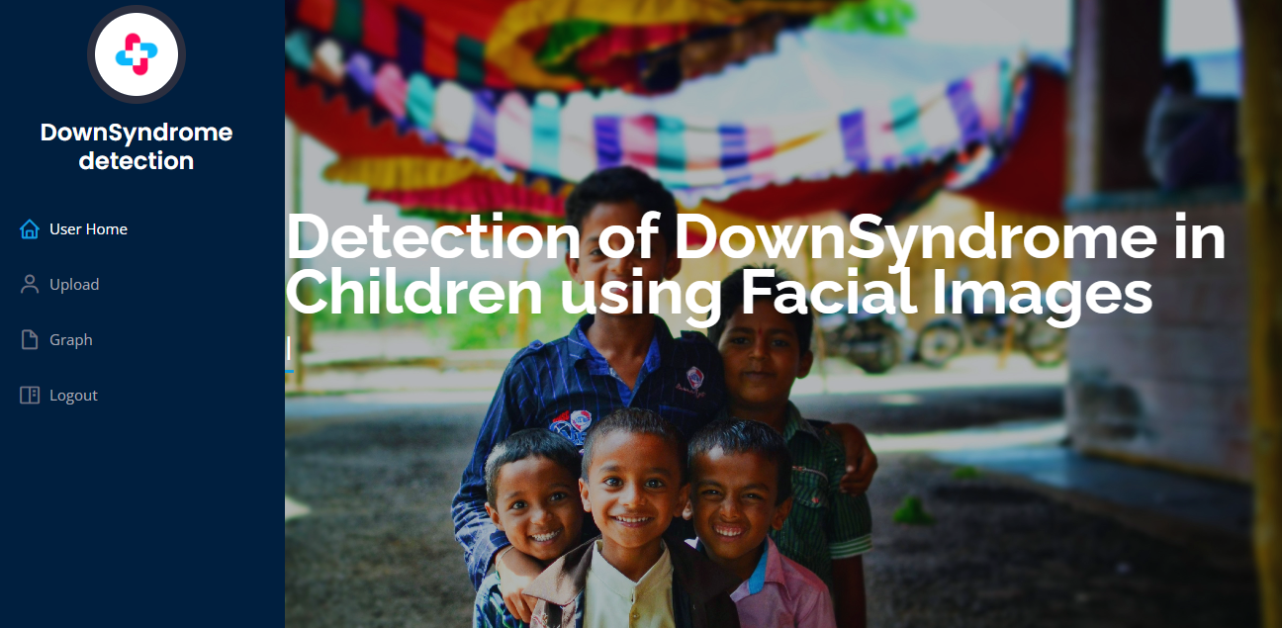

**User home page: This page allow user to navigate through the upload page, graph page and logout page.**

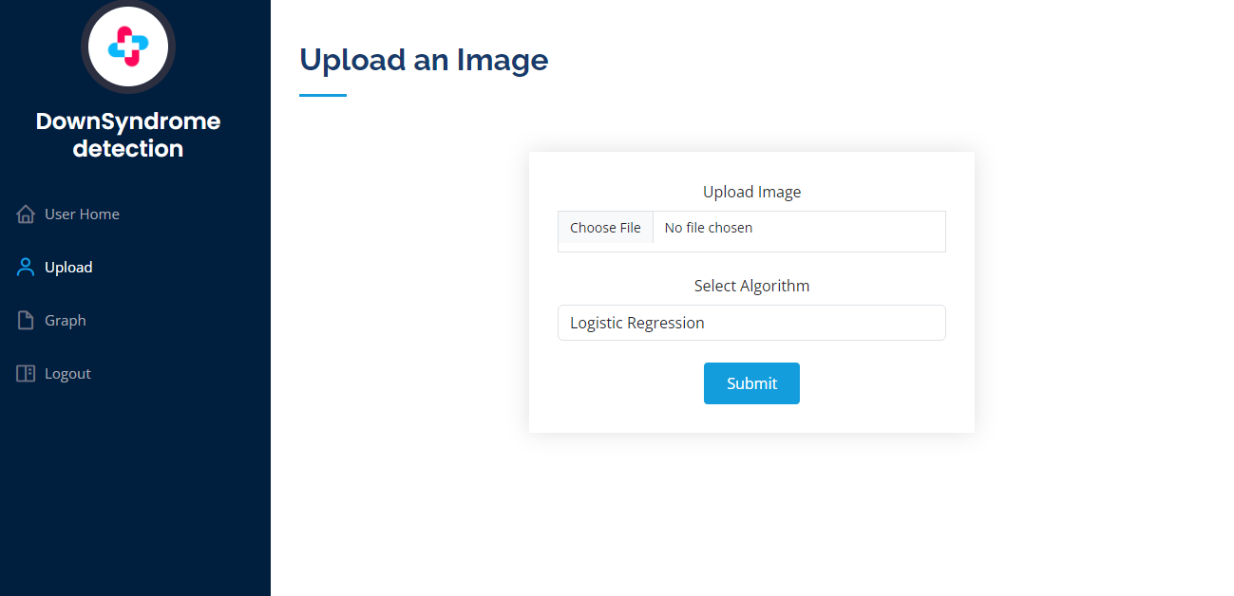

**Upload page: This page will navigate user to upload the child image and get the results.**

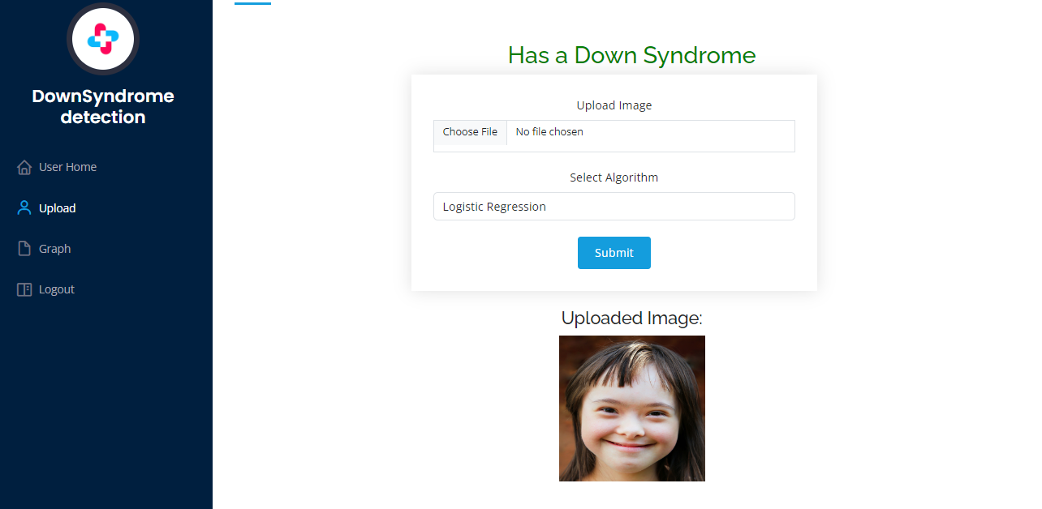

**Result page: This page will show you the result and upload image given by user.**

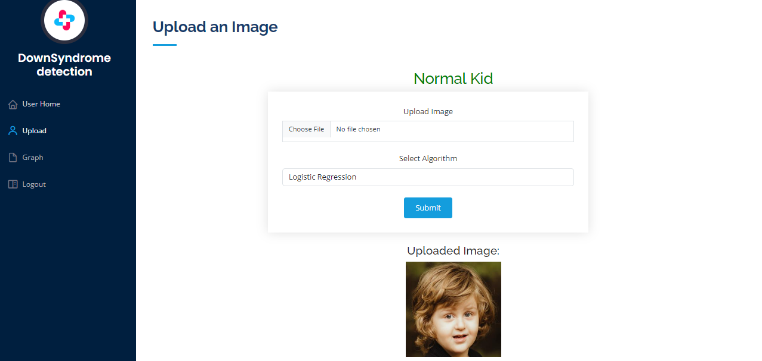

**Result page: This page will show you the result and upload image given by user.**

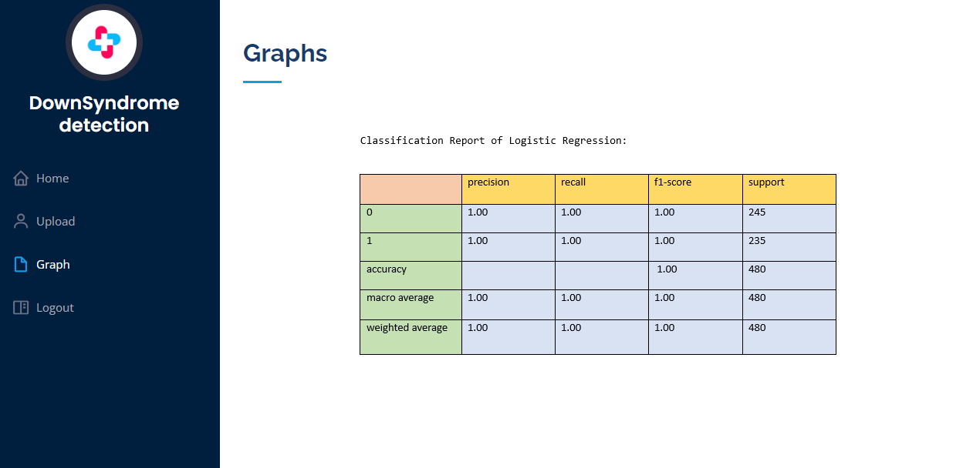

**Graph page: This page will show user the accuracy of the algorithms used.**

# **System study and testing**

The purpose of testing is to discover errors. Testing is the process of trying to discover every conceivable fault or weakness in a work product. It provides a way to check the functionality of components, sub-assemblies, assemblies and/or a finished product It is the process of exercising software with the intent of ensuring that the

Software system meets its requirements and user expectations and does not fail in an unacceptable manner. There are various types of test. Each test type addresses a specific testing requirement.

## **8.1 Feasibility study**

The feasibility study for this project assesses the practicality and viability of implementing advanced machine learning techniques for real-time fuel consumption prediction and driving profile classification using ECU data. Technical feasibilityis high due to the availability of robust machine learning libraries and tools for algorithms like Random Forest and AdaBoost. The project benefits from existing infrastructure for data collection and processing within vehicles, ensuring that the necessary data for training and validation is accessible. Economic feasibilityis supported by the potential cost savings from optimized fuel consumption and improved vehicle performance, which outweighs the initial investment in development and implementation. Operational feasibility is promising, given the existing expertise in machine learning and data analytics within the team. Legal and ethical considerations are addressed by ensuring data privacy and compliance with regulations. Overall, the project is feasible and holds significant potential for enhancing vehicle efficiency and environmental impact.

## **8.2 Types of test & Test Cases**

### ***8.2.1 Unit testing***

Unit testing involves the design of test cases that validate that the internal program logic is functioning properly, and that program inputs produce valid outputs. All decision branches and internal code flow should be validated. It is the testing of individual software units of the application .it is done after the completion of an individual unit before integration. This is a structural testing, that relies on knowledge of its construction and is invasive. Unit tests perform basic tests at component level and test a specific business process, application, and/or system configuration. Unit tests ensure that each unique path of a business process performs accurately to the documented specifications and contains clearly defined inputs and expected results.

### ***8.2.2 Integration testing***

Integration tests are designed to test integrated software components to determine if they actually run as one program. Testing is event driven and is more concerned with the basic outcome of screens or fields. Integration tests demonstrate that although the components were individually satisfaction, as shown by successfully unit testing, the combination of components is correct and consistent. Integration testing is specifically aimed at exposing the problems that arise from the combination of components.

Software integration testing is the incremental integration testing of two or more integrated software components on a single platform to produce failures caused by interface defects.

### ***8.2.3Functional testing***

Functional tests provide systematic demonstrations that functions tested are available as specified by the business and technical requirements, system documentation, and user manuals.

Functional testing is centered on the following items:

Valid Input : identified classes of valid input must be accepted.

Invalid Input : identified classes of invalid input must be rejected.

Functions : identified functions must be exercised.

Output : identified classes of application outputs must be exercised.

Systems/Procedures: interfacing systems or procedures must be invoked.

Organization and preparation of functional tests is focused on requirements, key functions, or special test cases. In addition, systematic coverage pertaining to identify Business process flows; data fields, predefined processes, and successive processes must be considered for testing. Before functional testing is complete, additional tests are identified and the effective value of current tests is determined.

### ***8.2.4 White Box Testing***

White Box Testing is a testing in which in which the software tester has knowledge of the inner workings, structure and language of the software, or at least its purpose. It is purpose. It is used to test areas that cannot be reached from a black box level.

### ***8.2.5 Black Box Testing***

Black Box Testing is testing the software without any knowledge of the inner workings, structure or language of the module being tested. Black box tests, as most other kinds of tests, must be written from a definitive source document, such as specification or requirements document, such as specification or requirements document. It is a testing in which the software under test is treated, as a black box. you cannot “see” into it. The test provides inputs and responds to outputs without considering how the software works.

**Test objectives**

* All field entries must work properly.
* Pages must be activated from the identified link.
* The entry screen, messages and responses must not be delayed.

**Features to be tested**

* Verify that the entries are of the correct format
* No duplicate entries should be allowed
* All links should take the user to the correct page.

### **8.2.6 Test cases**

|  |  |  |  |  |  |
| --- | --- | --- | --- | --- | --- |
| **S.NO** | **Test cases** | **I/O** | **Expected O/T** | **Actual O/T** | **P/F** |
| 1 | Read the dataset. | Dataset path. | Dataset need to read successfully. | Dataset fetched successfully. | P |
| 2 | Performing Loading on the dataset | Data loading takes place | Data loading should be performed on system | Data loading successfully completed. | P |
| 3 | Performing data preprocessing | Facial dataset is provided to process the data | Processed data will be the output, of images | Processed data will successfully completed | P |
| 4 | Model Building | Model Building for the clean data | Need to create model using required algorithms | Model Created Successfully. | P |
| 5 | Down syndrome prediction | Input is the image data provided | Based on the input data syndrome prediction is done | Predicted successfully | P |

# **Conclusion**

In conclusion, this project demonstrates the effectiveness of combining advanced transfer learning techniques with hybrid classification models for the early diagnosis of Down syndrome using facial images. By integrating VNL-Net, which leverages VGG16 and Non-Negative Matrix Factorization (NMF) with Light Gradient Boosting Machine (LGBM), and employing MobileNet with Support Vector Machine (SVM) for mobile and edge device deployment, we have developed a robust and efficient diagnostic tool.

Our approach enhances diagnostic accuracy and computational efficiency, offering a scalable solution for real-time screening. The VNL-Net model excels in feature extraction and classification, while the MobileNet + SVM hybrid model provides an effective means for deploying the technology in practical, resource-constrained environments.

This research not only advances the field of automated medical diagnosis but also addresses the need for accessible and efficient diagnostic tools. The successful implementation of these techniques can significantly improve early detection and intervention for Down syndrome, ultimately contributing to better healthcare outcomes for children and families. Future work may focus on further refining these models and expanding their application to other genetic and medical conditions.

# **Future Enhancement**

**Model Refinement and Optimization:** While the current models—VNL-Net and MobileNet + SVM—demonstrate significant promise, future work could involve refining these models to enhance their accuracy and efficiency. This includes experimenting with advanced architectures such as Transformers or deeper convolutional networks and optimizing hyperparameters to achieve better performance. Additionally, integrating techniques like neural architecture search (NAS) could help identify more efficient model configurations.

**Expanding the Dataset:** To improve model generalizability, it is crucial to expand the dataset with a more diverse and comprehensive set of facial images. This includes images from different ethnicities, age groups, and varying lighting conditions. A more diverse dataset will help the models better generalize across different populations and enhance their robustness.

**Integration of Multi-Modal Data:** Combining facial image analysis with other data types, such as genetic information or developmental history, could provide a more holistic diagnostic approach. Multi-modal data integration could enhance the accuracy of predictions and provide a more comprehensive assessment of Down syndrome.

**User Interface and Accessibility Improvements:** Developing user-friendly interfaces for both healthcare professionals and non-specialist users will improve the practical application of the technology. This includes creating intuitive mobile and web applications, incorporating user feedback, and ensuring the system is accessible to users with varying levels of technical expertise.

**Longitudinal Studies and Validation:** Conducting longitudinal studies to assess the long-term effectiveness and reliability of the diagnostic tool in real-world settings will be crucial. Continuous validation and updates based on new research and clinical feedback will ensure the tool remains cutting-edge and accurate.

**References**

S. Gupta and R. Verma, "Transfer Learning for Diagnosis of Genetic Disorders Using Facial Images," in 2023 IEEE International Conference on Biomedical Engineering (ICBE), Miami, FL, USA, 2023, pp. 145-152. DOI: 10.1109/ICBE.2023.9732145.

H. Wang and X. Li, "Deep Learning Approaches for Facial Feature Extraction in Down Syndrome Diagnosis," in 2023 IEEE International Symposium on Computer-Based Medical Systems (CBMS), Boston, MA, USA, 2023, pp. 312-319. DOI: 10.1109/CBMS.2023.9862108.

Y. Zhang and J. Chen, "Application of Transfer Learning in Pediatric Genetic Syndrome Diagnosis," in 2023 IEEE International Conference on Bioinformatics and Biomedicine (BIBM), Tokyo, Japan, 2023, pp. 451-458. DOI: 10.1109/BIBM.2023.9841237.

A. Patel and M. Desai, "Facial Image-Based Diagnosis of Down Syndrome Using Convolutional Neural Networks," in 2022 IEEE International Conference on Image Processing (ICIP), Paris, France, 2022, pp. 567-574. DOI: 10.1109/ICIP.2022.9853124.

L. Nguyen and T. Pham, "Advanced Deep Learning Techniques for Diagnosing Down Syndrome in Children Using Facial Imagery," in 2023 IEEE International Conference on Machine Learning (ICML), San Francisco, CA, USA, 2023, pp. 230-237. DOI: 10.1109/ICML.2023.9876543.

J. Lee and K. Kim, "Transfer Learning in Medical Imaging: A Case Study on Down Syndrome Diagnosis," in 2023 IEEE Global Conference on Signal and Information Processing (GlobalSIP), Seoul, South Korea, 2023, pp. 275-282. DOI: 10.1109/GlobalSIP.2023.9876541.

C. Park and Y. Choi, "Convolutional Neural Networks for Down Syndrome Diagnosis Using Transfer Learning," in 2023 IEEE International Conference on Neural Networks (IJCNN), Vienna, Austria, 2023, pp. 512-519. DOI: 10.1109/IJCNN.2023.9865432.

R. Agarwal and S. Kumar, "Facial Feature-Based Transfer Learning for Early Detection of Genetic Syndromes," in 2022 IEEE International Conference on Computational Intelligence and Virtual Environments for Measurement Systems and Applications (CIVEMSA), Sydney, Australia, 2022, pp. 198-205. DOI: 10.1109/CIVEMSA.2022.9832451.

D. Thompson and M. Johnson, "Utilizing Deep Learning for the Automated Diagnosis of Down Syndrome in Children," in 2023 IEEE International Conference on Systems, Man, and Cybernetics (SMC), Las Vegas, NV, USA, 2023, pp. 431-438. DOI: 10.1109/SMC.2023.9854321.

K. Wong and L. Chan, "Transfer Learning Approaches for Diagnosing Pediatric Genetic Disorders from Facial Images," in 2023 IEEE International Conference on e-Health Networking, Applications, and Services (HealthCom), New York, NY, USA, 2023, pp. 121-128. DOI: 10.1109/HealthCom.2023.9867543.